Phys 157 Lecture Notes
Christopher Kalitin

11.4 / 17.5 Reading notes:
Stress is a measure of the forces causing deformation. Strain is proportional to stress.
Strain is a measurement of the deformation.

1 psi = 6895 Pa (N/m^2)

Kg to Newtons is done with the force of gravity. 1 Kg * 9.8m/s^2 = 9.8 N

Tensile = pulling forces, compressive = pushing forces

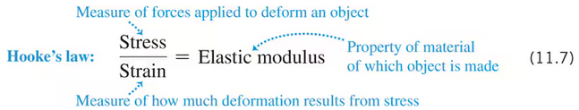
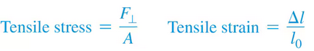
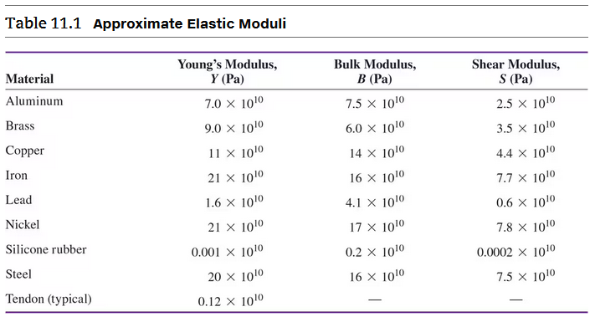

Heat refers to energy in transit, not total energy in a system. Eg. you heat water from 1 to 2 degrees celsius so its energy increases.
You can also sub in num moles (n) * Molar mass (M) in place of mass (m).
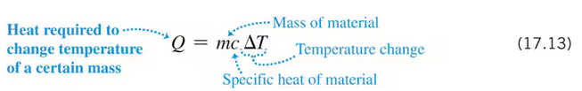

Sep 18 2024, Lecture 7:

For a string pulled by 40N from one end, bound at the other end. Both sides have equal and opposite forces, 40N. The tension is a constant 40N and the net force is 0 if not accelerating.

Young’s modulus = Y = stress/strain

Hooke's law only applies to elastic deformation.

P/T = P/T

Sep 20 2024, Lecture 8:

F/A = Y * (dL / L0)

Force is considered negative for compressive stress. Negative delta L.

Sep 23, 2024, Lecture 9:

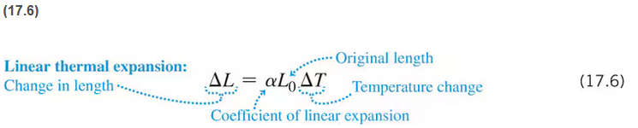

Week 4 Readings:
17.6/17.7

1 kg water increasing 100 C = 3.34 * 10^5 J/Kg

Q = mL
M = mass
L = latent heat required for specified phase change

Heat of fusion = Lf = heat required to melt
Heat of vapourization = Lv = liquid to gas

Water Lf = 3.34 * 10^5 J/Kg
Water Lv = 2.256 * 10^6 J/Kg
These constants depend on pressure.

Q = mct is for temp changes in a single phase
Q = mL is for phase changes (eg. solid at 0 C to liquid at 0 C)

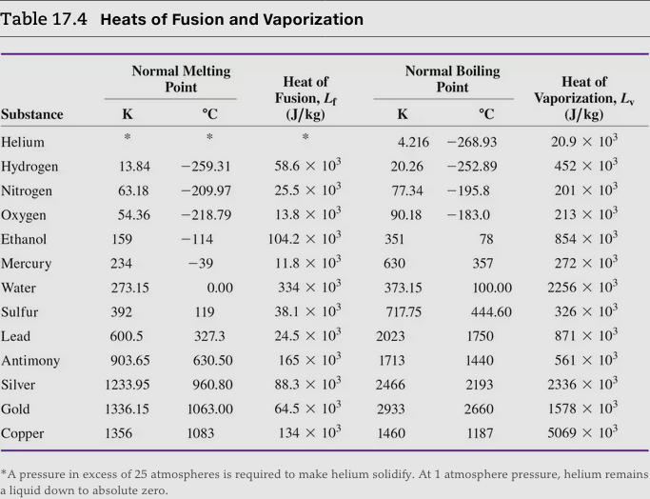

Calories in food refer to combustion of the carbon and hydrogen atoms with oxygen.

Conduction, Convection, Radiation.

Free electrons can move heat, the same principle as the flow of electricity.

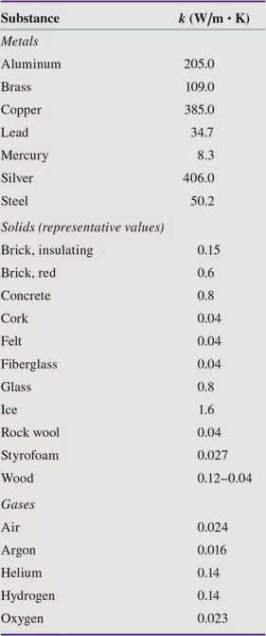
H = dQ/dT - Heat current, heat over temp

H = kA * (Th - Tc)/L
kA = thermal conductivity
Th - Tc = delta T over length

H = -kA * (dT/dx)
This is used if the temperature is nonuniform over an object
Negative means the heat flows to the lower temp.

H = A(Th-Tc)/R
R = Thermal resistance

R = L / K
L = thickness
K = ? kelvin?

H = A*e*sigma*T^4
A = Area
e = emissivity
Sigma = Stefan-Boltzmann constant
T = absolute temperature

Stefan-Boltzmann constant: 5.670 * 10^-8 W/m^2*K^4
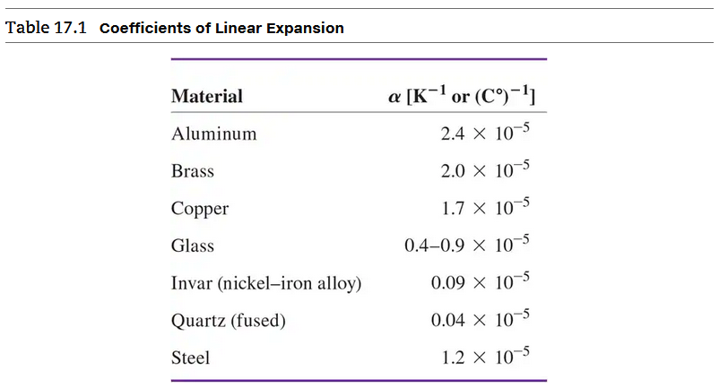

Sep 25 Lecture:

Complicated materials have higher specific heat capacities because part of the energy goes to rotation/vibration of the molecules instead of just velocity.

Q = mct

17.7 Week 5 Reading Notes:
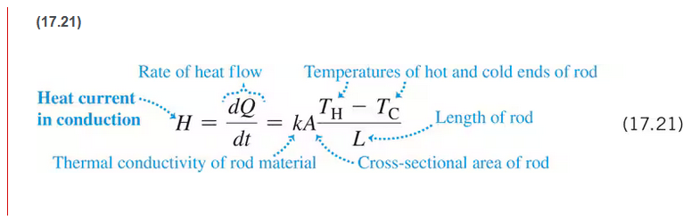
H = heat current

H = dQ/dt

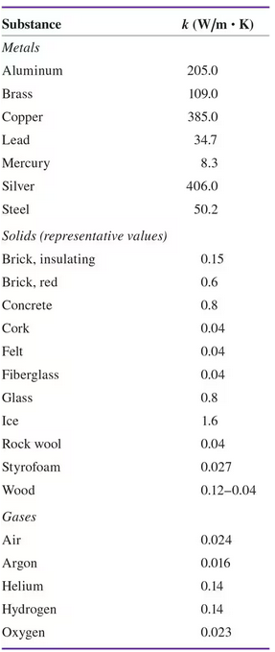
R = Thermal Resistance
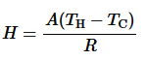
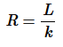
Si Unit of R:
m^2 * K/W

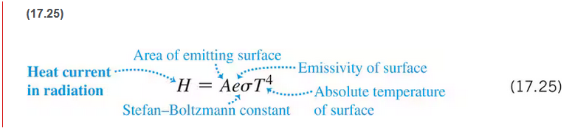
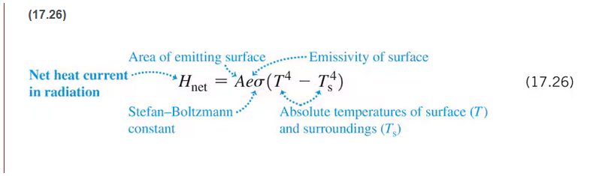

Oct 2 Lecture - Thermal Conductivity:

H = rate of change of thermal energy / how fast it flows
H = J/s = W

This is the slope of the graph of the heat flow:
dT1/dt = -(kA/mcL)*T12
T1 = temp 1
T2 = temp 2
T12 = T1-T2

Oct 4 Lecture - Radiation and Conductivity:

Oct 7 Lecture - Radiation:

Wien displacement law: lambda max = b/T
B = 2.9 K * mm
Maximum wavelengths is inversely proportional to temperature

e = H / H blackbody
E = emissivity
H blackbody = perfect absorber

Positive net heat current (H net) = emitting

Oct 11 Lecture - Ideal Gas Law:

P1/T1 = P2/T2
P vs T graph is linear

First law of thermodynamics:
Delta U = Q - W
delta U = change in energy - Also equals delta E, change in energy
Q = Heat added
W = work done / heat removed

P = const * (N/V) * m * v^2
N/V = number of molecules, mols / volume - density

Velocity is squared because there are 2x the collisions and 2x the momentum.

Temperature is proportional to pressure
Temperature is proportional to average kinetic Energy

P = constant * (N/V) * T
Constant = R / Na - R = gas constant - Na = Avogadro's number 6.02e23
N = number of molecules

PV = nRT
n = N/Na - molecules / mole constant = moles

W = Fd
P = F/a

Week 7 Reading 19.3-19.8:

The pV diagram shows the path through a series of intermediate states.

Adiabatic = “no heat transfer”
Isochoric = “constant volume”
Isobaric = “constant pressure”
Isothermal = “constant temperature”

Adiabatic expansion = positive W

For an ideal gas, internal energy U depends only on temperature, not pressure of volume.

We use the specific heat capacity for constant volume and constant pressure constants. Cv, Cp.
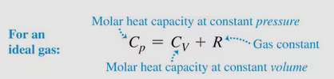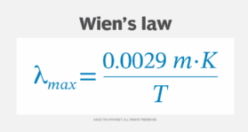

Albedo = 1 - emissivity
Intensity = I = W/(4*pi*r^2)
H = Aeo(Th^4 - Tc^4)

Oct 16 Lecture:

If the direction of the force and the direction of the displacement are the same, then the work is positive. W = Fx

Wgas = P * dV
W = work
P = pressure
dV = change in volume

Under compression, gas does negative work. Under expansion, Wgas is positive.

The si unit for volume is m^3, you need to multiply liters by 10^-3.

Sign of the work only depends on change in volume, not change in pressure.

Oct 18 Lecture - First law of thermodynamics:

Create the function for pressure as a function of volume.
y = f(x) where y is pressure and v is volume

Practice this shitty derivative integral shit.

dU = Q = nCvdT

Cv = Molar specific heat at constant volume

U = N * E (average kinetic energy)
N = molecules

E = const * T
Const = 3/2 * R/Na <- This is from kinematic theory, not covered in this course
The 3 depends on the degrees of freedom, 3 is for a monoatomic gas

R = gas constant = 8.314
Na = Avogadro's number

U = 1.5nRT

Oct 21 Lecture:
dU of an ideal gas depends only on T and n. Temperature and moles.

dU = n*Cv*dT

Adiabatic = no heat transfer

T2/T1 = P2/P1

Cp = Cv + R

Internal energy is proportional to temperature.

Work is negative if volume is decreasing.

d/dv(lnV) = 1/V

Oct 23 Lecture:

When V is constant, P/T = a constant. Opposite for pressure. Q = nCvdT (or Cp)
For isochoric and Isobaric, dU = nCvdT for both. Cv is used for both.

Isothermal = temperature constant, PV = const
W = Q = nRT*Ln(Vf/Vi) <- this simplifies so we don’t have to integrate

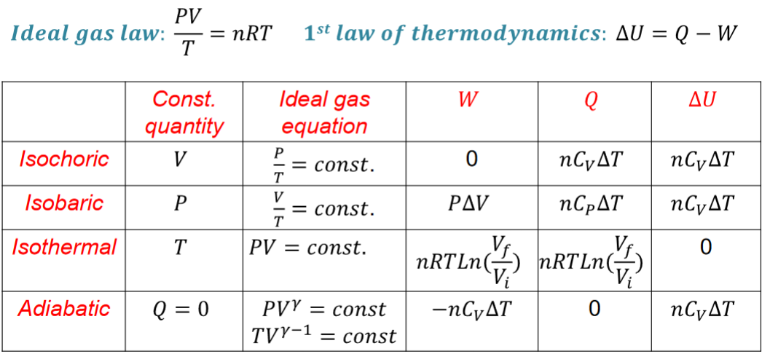

dU is dependent on temperature. If temperature is constant (Isothermal), change in internal energy is 0.

In a perfectly insulated container, Q = 0. Net heat flow is obv. zero.

The sign of dU and dT is the same.

Two cases of adiabatic process: Gas is well insulted or the process is very fast so no time for heat transfer.

First Law of Thermodynamics is dU = Q - W

Cv and Cp are the C values for specific heat capacity related to mass or moles.

Cp = Cv + R

Isothermal P = 1/V
Adiabatic P = 1/(V^y)
y = gamma
Gamma = Cp/Cv
“=” = proportional here

Work always equals P * dV

Oct 25:

“Very rapid” = adiabatic. Heat doesn’t have time to enter or leave.

Vi^(gamma-1) * Ti = Vf^(gamma-1) * Tf
Gamma = Cp/Cv
Cp = Cv + R <- only valid for ideal gasses

You shouldn’t memorize in physics, just know the fundamental equations and how to derive everything.

Efficiency is always positive, this is why we put the absolutes in the formula, not after.

Each step of the engine cycle is an approximation. No such thing in reality as adiabatic or isochoric.

Wnet = W_b->c + W_c->d …
^ Good way to model it, net work is the sum of the work through every individual process in an engine cycle

19.3-19.8 + 20.2-20.4 Notes:

As a gas does work to expand, its internal energy - hence temperature - drops.

Adiabatic processes do more work than isothermal processes. Why?

Compression in air compressors is adiabatic. An adiabatic process occurs when you quickly open the top of a soda can.

dU = nCvdT is for any ideal gas. Adiabatic or not.

R/Cv = y - 1

Adiabatic expansion always occurs with a drop in temperature.

Oct 28:

Coefficient of performance = abs(Qc)/abs(W)
Qc = heat removed

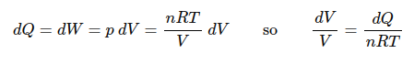

S = entropy
dS = dQ/T <- For infinitesimal reversible processes
dS = Q/T <- Reversible isothermal process

S = k ln(w)
k = Boltzmann constant (gas constant per molecule)
w = number of microscopic states for a given macroscopic state

dS = k ln(W2/W1) <- sometimes

If heat is flowing out of an engine, we put its energy as negative.
Qh = mass * latent heat of combustion <- for engines

Hp = W/746
746 Watts per Horsepower

Pi(Vi)^y = Pf(Vf)^y <- only for adiabatic
y = gamma = adiabatic

If you have gamma (y), you’re dealing with a diatomic gas, so you use 5/2 R for Cv.

Oct 30 Lecture Notes:

Expansion / Compression have to happen for work to be done.

dU is always nCvdT

First, consider each step individually and determine what reaction? Is occurring.

Coefficient of performance: k = Qc/W
How much work does it take to remove Qc joules from the cold side?

Nov 4:

In irreversible processes, the entropy of the system & environment increases. Vice versa.

Adiabatic processes are reversible. No heat exchange.

Isothermal processes are reversible only if there is no temperature delta with the environment.

Net dS for a system is zero. However, entropy is added to the environment.

Because you know the sum of all changes in entropy for a system is zero, you can solve for individual terms.

ENTROPY IS A STATE VARIABLE

Entropy is extensive (additive).

For all cycles net dU = 0, and by extension net dS = 0.

Nov 5 HW 7 Notes:
If heat flows into an object, its entropy increases. Don’t worry about T in the denominator.

The area under the TS curve is Q.

Nov 6:
dS for Isochoric = nCvLn(Tf/Ti)
dS for Isobaric = nCpLn(Tf/Ti)

Efficiency of a Carnot Cycle: e = 1 - (Tc - Th)
We can express a Carnot Cycle as either a PV graph or TS graph, TS graph makes solving for efficiency far easier.

Hooke’s law only works for ideal springs. In reality, the slope of the F vs. dX graph is not perfectly linear except near the origin.

Nov 8:
We can’t use kinematics equals for spring problems because force and acceleration are changing.

Only increasing

Omega = sqrt(k/m)

Midterm 2 Notes:

The formula for surface area always contains r^2!! Not r^3 or r!

Nov 22 Notes:

b is the coefficient that describes the drag coefficient.
F is proportional to v^2

b = damping constant

Fnet = -kx - bv

A = amplitude = max x

T_0 = 2m/b <- Time constant

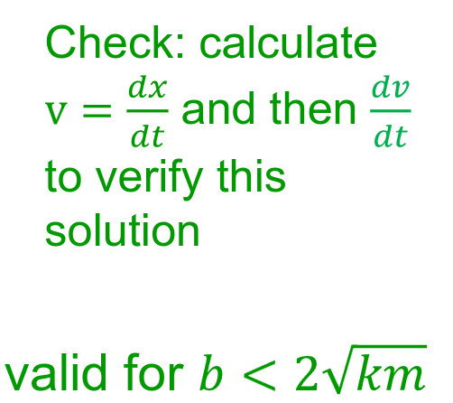
Viscous fluid drag formula:
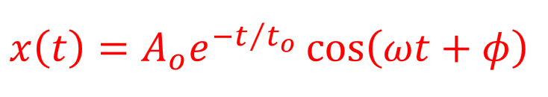

With these formulas we can find an inequality:
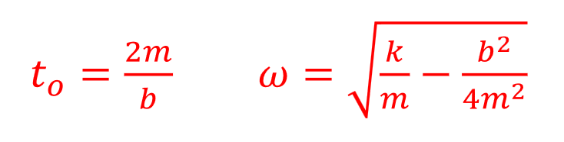

When b = 2*sqrt(k*m), we have critical damping - Pure decay no oscillations.

For a given A_0, you can use this formula to solve to t_0:
Use log to cancel out e
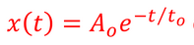

T_0 is when f(y) = 1/e * f(x)
So, 0.37 ish of the original value.

Resonance is when the frequency of the driving force matches the natural frequency of a system.

Nov 25 Notes:

We call it a forced oscillation.

Longitudinal is oscillation that is in line with a string.
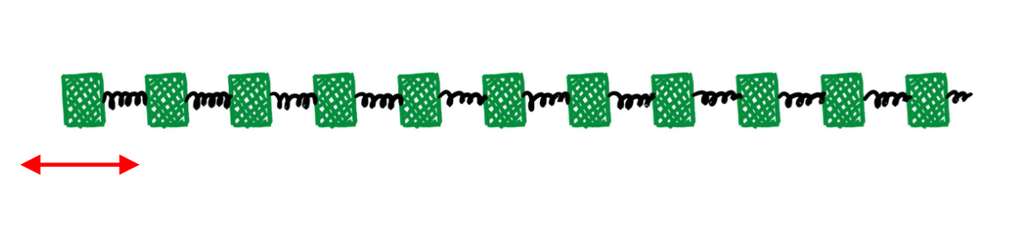
You get areas of high pressure and low pressure.

This is in contrast to transverse waves.

Y vs. X graphs move to the right as time increases. It shows displacement, and the shape of the graph is shifted right.

Nov 29:

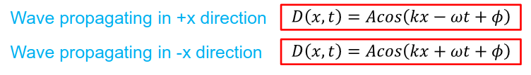

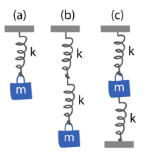
Final Studying Notes
When you have two springs attached to each other, the spring constants don’t add up.

In the image on the right, the springs on (b) are effectively just a single spring with constant k. NOT 2k.

D(x, t) graphs only show you the wave length. From here you use v = L/T, to find wave speed given period.

Period is the time it takes for the wave to move up one wavelength, so effectively it looks exactly the same.

v = Lf

